* + **INSERT INTO**

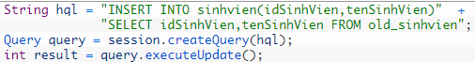

* + **UPDATE**

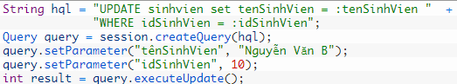

* + **DELETE**

